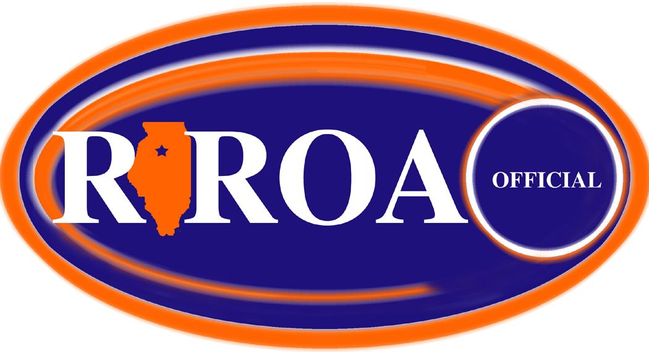

Rock River Officials Association

General Membership Meeting Minutes of Sunday, February 28, 2021
…held at CGH Medical Center - Sterling, IL…

Attendance: 17 members present

Dave Trueblood Chris Breitbach Jim DuBois Les Huisingh
Dave Olinger Ken Wilcoxen Kris Wilcoxen Scot Sutherland
Steve Haring Tyler Vogt Jon Santos John Kereven
Tom Starr Kevin Carroll Therol Anderson Brad Steinhagen
Tom Nance

General Membership Meeting called to order at 5:02 pm by Chris Breitbach

Call for New Members: by Chris Breitbach
- None

Treasurer’s Report: by John Kereven
- Current balance of $2532.60.
- Motion to approve by Jim Dubois. 2nd by Bill Wescott. Passed unanimously.

Secretary’s Report: by Tom Frank
- Minutes for 11-10-19 submitted to membership via email.
- Motion for approval by Ken Wilcoxen. 2nd by Dave Olinger. Passed unanimously.

Media/Web/IHSA Report: by Dave Trueblood.
- Creating a list of assignors for RROA per sport.

Call for Old Business: by Chris Breitbach…

- Committee for Football Officiating Class - tabled again

- Review of Incentive Program.
  - Discussed and decided to approve for another year. Motion by Tom Starr. 2nd by Jim Dubois. Voted and majority voted to approve.
  - Keith Medema presented an idea for new members. New officials who attend ½ general and ½ sport specific receive a gas card for $25 at the end of the season. Motion by Dave Trueblood. 2nd by Dave Olinger. 13-6 approval majority vote.

Call for New Business: by Chris Breitbach

- Nomination of delegates for the state convention. Gary Taylor and Tom Starr were in attendance and plan on attending the convention. Les Huisingh will also be in attendance. Motion to approve Gary Taylor and Tom Starr as delegates by Jim Dubois. 2nd by Dave Olinger. Unanimously approved.

- Lifetime RROA Honorary Member nominations. Les Huisingh and Dave Trueblood were nominated by committee. Motion by Tom Starr. 2nd by Ken Wilcoxen. Unanimously approved.

- Basketball Meetings Wrap-up by Dave Trueblood. Around 14 were consistently at meetings. Discussions went
well and the interactions were critical.

- RROA IHSA Post-season Assignments by Tom Frank.

Football Fall 2019

Les Huisingh: Round 1 - Morton HS 5A
Round 2 - Sterling Newman 2A
Round 3 - Lena-Winslow 1A
Round 4 – Coal City 4A
State Finals – DeKalb 3A

Ken Wilcoxen: Round 1 - Mercer County 2A
Round 2 - Morrison 1A

Jon Santos: Round 1 - Rockford Boylan

Scot Sutherland: Round 1 - Lombard East

Volleyball Fall 2019

Brad Steinhagen: Regional - Annawan 1A

Tom Starr: Regional - Princeton 2A
Supersectional – L/P Line Judge 3A

Basketball 2019/20

Ken Wilcoxen: Regional - 1A Boys (Full)
Sectional – River Ridge 1A Boys (Partial)

Larry Rehmert: Regional – Winnebago Boys (Full)
Sectional - River Ridge 1A Boys (Partial)

Jim Kalina: Regional – L/P Boys 3A

Les Huisingh: Regional - River Ridge (Partial)

Jim Dubois: Regional - River Ridge (Partial)

Dave Trueblood: Regional - Amboy 1A Girls (Full)
Regional - Sycamore 3A Girls (Partial)
Sectional – Pecatonica Girls 1A (Full)
Supersectional – Dekalb Girls 2A
State – Bloomington Girls 1A/2A

- Four signs to be purchased by Dave Gilliland to use for the association clinics ($140 total). Motion for approval by
Dave Olinger. 2nd by Larry Dessing. Passed unanimously.

- Other business:
- Officials not showing up for games.
- Update arbiter by November 30th for post-season
- Card for Mario. Motion by Tom Starr. 2nd by Steve Haring. Passes unanimously.

Incentive gift card winner was Keith Medema

Motion for adjournment by Steve Haring. 2nd by Jim Jecklin. Passed by Membership
Meeting adjourned at 5:55

Prepared by: Tom Frank, Secretary – Rock River Officials Association

