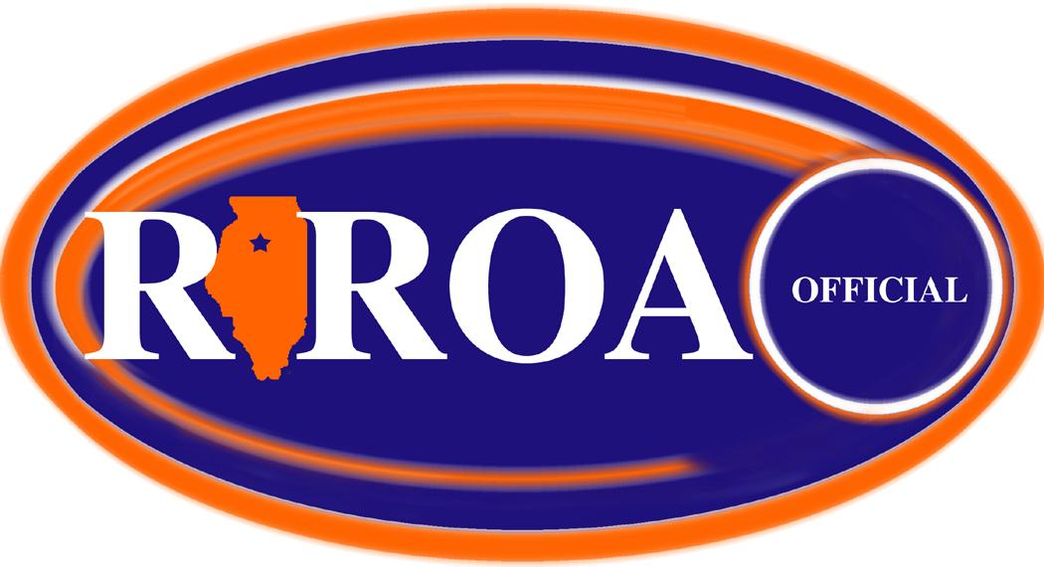

Rock River Officials Association

General Membership Meeting Minutes of Sunday, May 16, 2021
…held at CGH Medical Center - Sterling, IL…

Attendance: 16 members present

Dave Trueblood Scot Sutherland Chris Breitbach Tom Nance
Dave Olinger Gary Taylor John Kereven Jon Santos
Therol Anderson Larry Rehmert Jim DuBois Ken Wilcoxen
Kris Wilcoxen Les Huisingh Roger Thinnes Tom Starr

General Membership Meeting called to order at 5:03 pm by Chris Breitbach

Call for New Members: by Chris Breitbach
- None

Treasurer’s Report: by John Kereven
- Current balance of $1859.52
- Motion to approve by Jim Dubois. 2nd by Dave Olinger. Passed unanimously.

Secretary’s Report: by Dave Trueblood
- Minutes for the 2-28-21 general membership meeting submitted to membership via email.
- Motion for approval by Ken Wilcoxen. 2nd by Dave Olinger. Passed unanimously.

Call for Old Business: by Chris Breitbach

- Election of Officers Committee --- Ken Wilcoxen
- Ken Wilcoxen presented a list of potential candidates
President …………….Jim DuBois
Vice President ………Jon Santos
Secretary ……………Tom Nance
Treasurer ……………John Kereven
Game Assignor ……..Jim Kalina
Web-Media-IHSA …..Dave Trueblood
At-Large #1 …………Kris Wilcoxen
At-Large #2 …………Scot Sutherland

- RROA Meeting Schedule / 2021-22 Season --- Dave Trueblood
- Informed membership that the first two general membership meetings would be on 8/1/21 & 8/15/21.
- Remaining schedule will be similar to past schedules (pre-Covid) with notable changes required by members. Holidays & pro football schedules would be taken into consideration.

- Other --- Membership
- Tom Starr informed membership that Gary Taylor is “hanging up his steel toed plate shoes” after 31 years of baseball officiating. NOTE- Gary had already retired from basketball after 40 years.

Page 2 – May 16, 2021

Call for New Business: by Chris Breitbach

- RROA Post-Season Meeting Needed --- Dave Trueblood
- Members felt there was no need for additional meetings for baseball & softball.

- RROA Basketball Clinic (Dave Gilliland) --- Dave Trueblood
- Read the prepared information from Dave G regarding the clinic.
- One clinic at Winnebago HS 6/9/21, 6/11/21, 6/12/21.
- Another clinic on 11/14/21. Site and times TBD.

- Membership Dues for 2021-22 Season --- Chris Breitbach
- Members were informed that all existing members from the 2020-21 Covid season would not need to pay any dues for the upcoming season.
- However, any past members or new members would need to pay dues.
- The board of officers held a special session and determined the guidelines for this one season change.

- Other --- Membership
- Roger Thinnes informed membership on RROA Volleyball Clinic. Clinic will be held on 8/18/21 at Challand Middle School starting at 5pm lasting till 9pm.
- Roger Thinnes led discussion on assignors being involved with the IHSA Top15 listing credit. Much discussion was held about the pros & cons of this.
- General discussion and information provided about the two new assignors for the 3 Rivers Conference. Joe Thompson (Galesburg) will be the boys/girls basketball assignor. Mike Botts (Quad Cities) will be the baseball & softball assignor. Much discussion was held about the circumstances involved with these two non-area assignors handling this more local conference. Also, information was that basketball officials were going to be paid $135 per night to do both soph & varsity games. Runners could be used for the soph but come out of the $135 amount. One varsity official must be at or do the soph game as well.
- Chris Breitbach discussed giving a $200 donation to the CGH Auxiliary for the use of the conference room for meetings. Motion for approval by Ken Wilcoxen. 2nd by Kris Wilcoxen. Passed unanimously. John Kereven to handle.

Motion for adjournment by Dave Olinger. 2nd by Roger Thinnes. Passed by Membership
Meeting adjourned at 6:08pm.

Prepared by: Dave Trueblood, Acting Secretary – Rock River Officials Association

