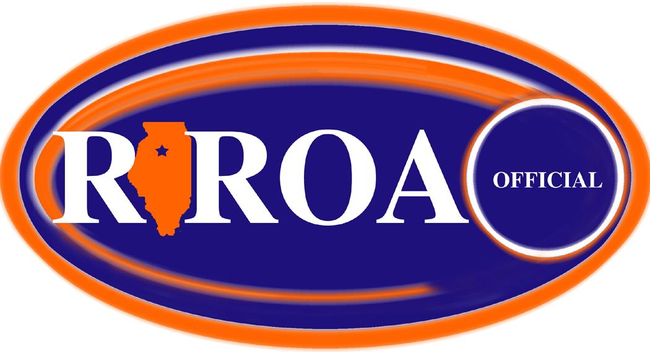

Rock River Officials Association

General Membership Meeting Minutes of Sunday, August 1, 2021
…held at CGH Medical Center - Sterling, IL…

Attendance: 22 members present
Dave Trueblood Therol Anderson Vern Tervelt Kris Wilcoxen
Ken Wilcoxen Roger Thinnes John Kereven Dave Gilliland
Tom Starr Les Huisingh Dave Olinger Larry Dessing
Scot Sutherland Chris Breitbach Tom Nance Brad Steinhagen
Steve Haring Brad Ebersole Jon Santos Tim Nelson
James DuBois Larry Rehmert

General Membership Meeting called to order at 5:02pm by Chris Breitbach

Congratulations given to Dave Olinger for being a 12U state final official in softball

Introduction of new assignor for softball/baseball: Mike Botts
Mike spoke at length about
His background
Use of Arbiter (every sub must go through him)
Fee structures
His evaluation plans of officials
Contact information: cell: 563-349-8831 email: mgbotts@aol.com
Assistant Wendy: 563-326-6261

Treasurer’s Report: John Kereven
Current balance: $1,659.52
Motion to approve by Larry Rehmert, second by Dave Olinger. Passed unanimously.

Secretary’s Report: Dave Trueblood
Report sent via email prior to the meeting for member’s review.
Motions to approve by Ken Wilcoxen, second by John Kereven. Passed unanimously.

Election of Officers: Dave Trueblood / Ken Wilcoxen
Ballots were distributed and collected.
Elected Officers:
President Jim Dubois
Vice President Jon Santos
Secretary Tom Nance
Treasurer John Kereven
Assignor Jim Kalina
Web/IHSA Dave Trueblood
At Large #1 Kris Wilcoxen
At Large #2 Scot Sutherland
New Members proposed and accepted
Tim Nelson, Brenda Gould, Brad Ebersole
Motion to approve: Ken Wilcoxen; second by Tom Starr. Passed unanimously.

Old Business
IHSA Summer discussion: Tom Starr suggested viewing video from IHSA summer conference as a tool for general official education. This could happen at the next general membership meeting.

New assignor discussion

RROA Volleyball clinic (Tom Starr/Roger Thinnes) - see date on RROA meeting schedule

RROA Basketball clinic (Dave Gilliland/Tom Starr) - form passed out for the clinic on Nov. 14

Other: Discussion held on how to recruit new officials. Our membership is at 45.

New Business
2021-22 Sport Chairperson designated
Football Ken Wilcoxen Jon Santos Les Huisingh
V-ball Tom Starr Roger Thinnes
B-ball vacant
Softball Tom Starr Dave Olinger
Baseball Larry Dessing Tom Nance

IHSA Official of the Year committee
Chris Breitbach Brad Ebersole

IHSA Grant proposal- topic tabled for further discussion

Other- next meeting Aug.15

Motion for adjournment by Steve Haring, 2nd by Dave Olinger. Passed unanimously.
Time: 6:45pm

